M1C1 SCSS Assignment

*During the first section of Module 1, you will have been introduced to SCSS. SCSS is a superset of CSS. It allows you to use features like Variables, Mixins, For Each Directives, and more to style your HTML elements. SCSS is very useful for reducing your workload and increasing your speed. SCSS also helps your code be more efficient and versatile. Now that you have learned about SCSS, it is time to practice! Because SCSS requires a preprocessor to convert it to CSS, you will be using Codepen instead of a traditional text editor. Please complete the following assignment and reach out on the Support App to have a mentor review your work. If you have any questions or need any help, please reach out so we can help you! This assignment must be completed to pass this section of the coursework.*

*Concepts included in this assignment: HTML, CSS, SCSS, SCSS Variables, SCSS Mixins, SCSS Nesting, SCSS String Interpolation, CSS Text Color, CSS Background Color, CSS Margin, CSS Grid, CSS Grid Rows, Columns, and Fractional Units, CSS Flexbox, HTML Classes, HTML IDs, HTML Div, Img, and Paragraph Tags, and Codepen.

**Task 1**: Using HTML, create a div. Give it the class of “taskOne”. Inside this div, there should be one paragraph tag. Create an SCSS variable called “textColorOne”. This variable should store a color. Use the class to target the HTML div and use the SCSS variable to change the text color of the paragraph tag.

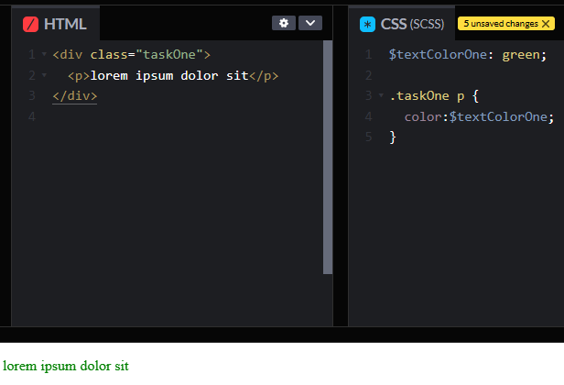

**Task 2**: Using HTML, create another div. Give it the class of “taskTwo”. Inside this div, create a paragraph tag. Using SCSS, create a mixin that includes the variable you already created. Set text color to equal the variable. Use the class to target the HTML div and include the SCSS Mixin, which will in turn apply the variable to change the paragraph tag’s text color.

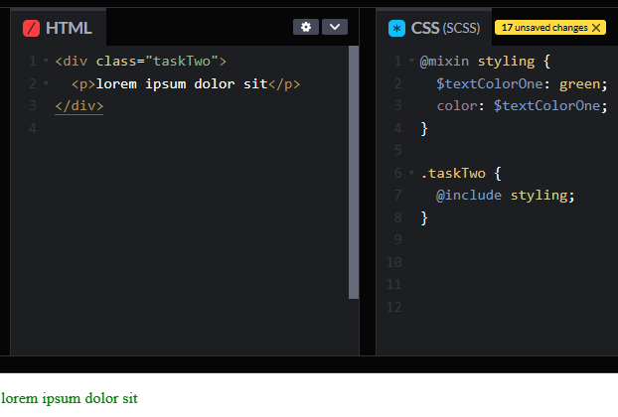

**Task 3**: Using HTML, create another div. Give it the class of “taskThree”. Inside this div, create another div tag. Give it a class of “nestedDiv”. Inside this div tag there should be another p tag. Using SCSS nesting, style the text color to equal red.

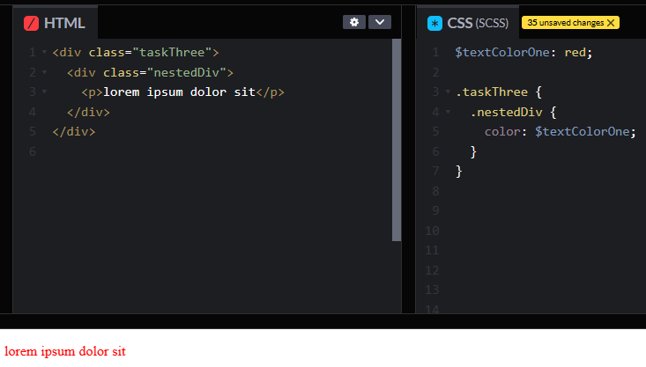

**Task 4**: Create a new variable named “backgroundColorOne”. Store a hexidecimal of #237C95. Create a new mixin called “mixinTwo” using SCSS that turns background color to the new variable. Also include height and width definitions that are equivalent to 200px. Add a margin of 10px to all sides. Create two divs each with the class of “taskFour”. Include the new mixin and style “taskFour”.

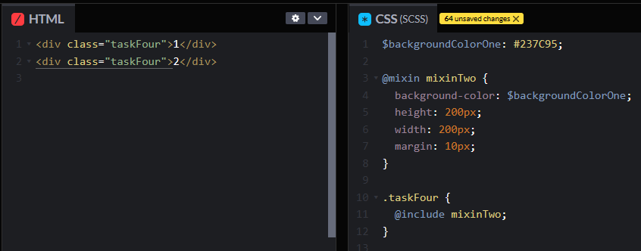



**Task 5**: Create a new variable named “backgroundImage”. In this variable, the name “maserati” should be stored. Make sure it is a string. Create a new div with the class of “taskFive”. Style the div by calling the class. Set the property background-image to the following: url('https://s3.amazonaws.com/bottega-devcamp/scss/cars/#{$backgroundImage}.jpg'). Set the width and height to 300px and set object-fit to fill.

